Digital Key in Primary Music Education
In pedagogical practice at the first stage of musical teaching the natural abilities of children were always taken into consideration, it is the main principle on which the pedagogical process is based. The child’s psycho-emotional status and neurophysiologic peculiarities of mechanisms of brain’s activity : perception of the information from the sheet, analysis and syntheses of the perceived pattern, realization of the neuro-motor function of hands on the keyboard of an instrument were not taken into consideration in due measure. Great sum study load is the cause of appearing negative emotions, lowers child’s interest to the music subject, as a result of it, the development of the child's natural musical abilities is restrained.
The pedagogic task at initial stage of teaching consists in that to give the intensive development to the natural gift of a child, rationally to realize his potential music possibilities in special psychosomatic action as a result. With this purpose the method of Digital Key has been elaborated. It is the system of musical training based on the mode of perception of music sounds by means of digits. The recommended technology is directed on the balanced and rational distribution of the sum study load to a child's psycho-emotional sphere, foresees the program organization of educational process, permits systemic to manage by sum study effect.
The physiological substantiation on application of the Digital Key for coding and decoding of a melody is the following : children begin their contact with digits already in preschool age, when they are taught to count and this system is learned by children quite firmly, since it is often used in their daily life. But the generally accepted music grammar is new for them and, naturally, requires some additional period of time to be acquired by children. It is for that reason that in the initial period of musical teaching, children inevitably spend a lot of time and efforts to read a melody written down in music signs. Naturally, it slows down rate of training, causes psycho-emotional discomfort, lowers the child’s interest to music. Therefore, in the initial period of teaching, besides work with the generally accepted music grammar, it will be useful to substitute it with the use of a digital system for some time. It does not mean that we want to do without standard music grammar but at the initial stages of musical education, the system of digital coding and decoding of music sounds is undoubtedly useful, as it speeds up teaching of children.
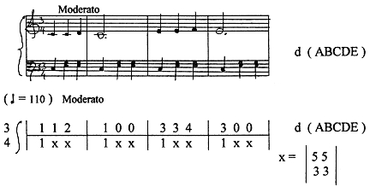
It is well-known that the difficulties in perception of any information, including musical one, cause strain of the main functional systems in the child’s organism. Dynamics of movements and actions is characterized by time, high-speed, spatially-time, power and other parameters. Given parameters reflect the complex neurophysiologic processes passing in leading functional systems of the child’s organism ( central nervous system, muscular system, and others ) also explain the interrelations of neuromuscular coordination in their kinetic and dynamic data, the appearing threshold potential of synapse fatigue, interrelations between the frequency and intensity of nervous impulses. With this purpose the experimental researches are to be performed, namely: ENG, EMG, EEG – tests on study the load appearing in the child’s psychic sphere. The methods of ENG and EMG joins the visual analyzer with neuro-motor function of the hands and explains, on the scientific point of view, the ratio between the load on muscles of eyes and hands’ muscles. One can see the interdependence between the perception of information (Readout Algorithm) and the synaptic transmission (Action Potential) and also it proves the possibility of development of muscular fatigue in hands depending on the quantity of eyeballs’ fluctuations. EEG-test allows to make up the diagrams of dynamics of the functional activity of neurons and synaptic structures during practical study on two different modes (Comparing Methods). The realization of the described scientific researches in this direction will allow us to approach closer to understanding of more subtle mechanisms of the child’s mental activity and to detect the neurophysiologic factors in promotion to the enhancement of the velocity, quality and efficiency of musical education.
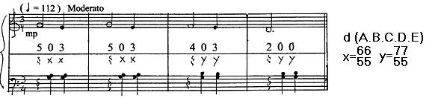
In practical work, while reading the generally accepted music information from sheet, the direction of eyeballs’ movements is spasmodic, it has a multi-stage combination both on y – vertical, from the G-key up to the F-key, and on x- horizontal often with return of eyesight to the initial point. For integration, synthesis and the modification of complex pattern of the received information the structures of the central nervous system require an additional period of time. It is a neurophysiologic process proceeding in an interval of time between the moment of perception of the music information from sheet and the moment of the hands’ response on the keyboard of an instrument. A great number of irregular nervous impulses is transferred to the central nervous system per unit of time and, as the consequence of this, fatigue of hand muscles is considerably increased. An amplitude of muscle tension is directly dependent on the stimulation frequency, when each subsequent nervous impulse coincides with the phase of increased excitability of a muscle. An important neurophysiologic moment has been noted : during a short time interval the contracture, i.e., constantly high muscular tension is formed, that in turn, is harmfully reflected on the contents and character of a melody.
In practical work while reading the digital information from sheet the trajectory of eyeballs’ movements on y–vertical is projected to the exact determinant ( digit, sign, symbol ), the trajectory of eyeballs’ movements on x – horizontal is projected in one direction, forwards. In the given system of dimension the integration of the digital information proceeds instantly, its realization on an instrument proceeds in reflexive time-ratio. The paradoxical phenomenon is revealed : the interval of time, between the moment of perception of the digital information from sheet and the moment of the hands’ response on the keyboard of an instrument, is contracted to a minimum. We achieve a reduction of load on hand muscles at the expense of decreasing of an amplitude between muscle tension and the resulting movement and, as a consequence of this, the time intervals between effort and accuracy of pressing of a key are considerably shortened. An important neurophysiologic moment has been noted: reciprocal muscular innervations is formed, i. e. the rational distribution of the manual technique on the keyboard of an instrument, that in turn, is considerably reflected on the contents and character of the melody.
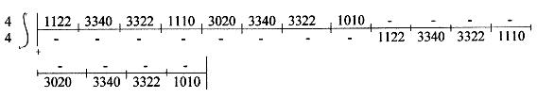
While applying the technology of Digital Key, the child rationally distributes the total study load on leading functional systems his organism, creates highly - accurate coordination without inclusion in practical activity of unnecessary muscle groups, unnecessary movements, excessive effort by pressing a key, and it means, he excludes possibility of appearing of false acoustic and muscular sensations, and as a result of it, instantly creates a firm neuron linkage which in our life we call as a skill of coordinated action. New technique that uses EEG data based on how we perceive patterns. Kids in modern world should receive the most effective education they deserve. http://reflectionmusic.ucoz.com/
NeuromusicGroup Reflection Ukraine

